Inspection Register

- Inspection By Appointment
- Open Home Attendee
- Property Management Inspection

Property Address: _______________________________________________________ Date: _____________________
Agency Company Name: ____________________________________________________________________________
Licensed Salesperson: ______________________________________________________________________________

Would you kindly record your details below. This is a compliance requirement under the REAA Health and Safety, privacy and Unsolicited Electronic message legislation.

Where did yu first see this advertised?

- Local Paper
- Property Guide
- Sign
- Trademe.co.nz
- Realestate.co.nz
- Other

Are you

- Researching
- Selling
- Buying
- Renting
- Investing
- Other

Name: ____________________________________________ Phone: __________________________________________
Address: _____________________________________________________________________________________________
Email: ________________________________________________________________________________________________
Other attendees’ names: ___________________________________________________________________________

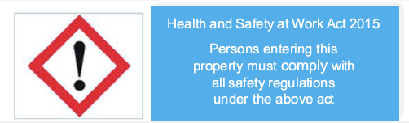
Hazards and Risks

All visitors must report to _______________________________________

Hazards | Risks | Control
1.
2.
3.

Health and Safely at Work Act 2015 Hazzard Acknowledgement:
I acknowledge I have read and understood the hazards and risks listed above.I agree to follow any instructions relating to the hazards explained to me by the salesperson from @realty Pty Ltd, Licensed (REAA 2008). I also agree to endure any person or children accompanying me will be supervised and follow the instructions provided.

Privacy Act 1993, Unsolicited Electornic Messages Act 2007:
I acknowledge and agree that the information provided to me is express consent and may be used by @realty Pty Ltd, Licensed (REAA 2008) and their associates for the purpose of security and marketing. By including my email details and mobile number I also consent to receive emails and texts containing property information regarding this and other property. I understand that I may unsubscribe at any time.

Signature: ________________________________________________________________________________________
Date: __________________________

